Experiment 3: Exploratory Data Analysis
Data Cleaning, Transformation & Visualization
Aim
To perform exploratory data analysis focusing on data cleaning, data transformation, and visual representation techniques on the Google Trends dataset (trends.csv). This covers identifying missing values, counting missing values, replacing missing values, removing duplicate records, detecting outliers, fixing incorrect data types, handling inconsistent formatting, and generating exploratory charts.
Software Requirements
- Operating System: Windows 10/11, macOS, or Linux
- Programming Language: Python 3.x
- Libraries Required: pandas, numpy, scipy, scikit-learn, matplotlib, seaborn
- Environment: Jupyter Notebook / Google Colab / VS Code
1. Identifying Missing Values
Identifying missing values is an essential step when analyzing data. Missing entries can distort analytical results and lead to unexpected errors during model training. In this step, we scan through all columns using boolean masking to highlight where missing values exist.
Code:
import pandas as pd
import numpy as np
import seaborn as sns
import matplotlib.pyplot as plt

# Load dataset
df = pd.read_csv('trends.csv')

# Boolean mask for missing entries
missing_mask = df.isnull()
print(missing_mask.head())
Output:
Search_Query Search_Volume Category Date_Recorded
0 False False False False
1 False False False False
2 False True False False
3 False False False False
4 False False False False

2. Count Missing Values
Counting missing values helps us see how incomplete each column is. Plotting a bar graph provides an immediate visual summary of columns requiring data imputation.
Code:
# Count missing values and visualize
missing_counts = df.isnull().sum()
print('Missing values per column:')
print(missing_counts)

# Plot missing value count bar chart
sns.barplot(x=missing_counts.index, y=missing_counts.values)
plt.title('Missing Values Count per Column')
plt.show()
Output:
Missing values per column:
Search_Query 0
Search_Volume 1
Category 2
Date_Recorded 0
dtype: int64
Visualization Plot:
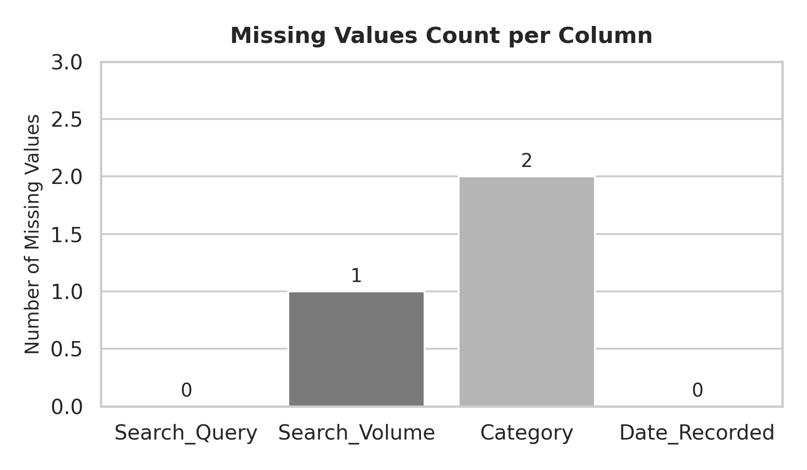

3. Replace Missing Values
Replacing missing values keeps the original size of the dataset intact. Numerical columns are imputed using the column mean, while categorical attributes are filled using the most frequent category.
Code:
from sklearn.impute import SimpleImputer

# Impute missing numerical and categorical values
num_cols = df.select_dtypes(include=['float64', 'int64']).columns
cat_cols = df.select_dtypes(include=['object']).columns

num_imputer = SimpleImputer(strategy='mean')
df[num_cols] = num_imputer.fit_transform(df[num_cols])

cat_imputer = SimpleImputer(strategy='most_frequent')
df[cat_cols] = cat_imputer.fit_transform(df[cat_cols])

print('Missing values after replacement:')
print(df.isnull().sum())
Output:
Missing values after replacement:
Search_Query 0
Search_Volume 0
Category 0
Date_Recorded 0
dtype: int64

4. Remove Duplicate
Duplicate records give undue weight to repeated rows and can cause overfitting during model training. Here, we locate exact duplicate rows across the dataset and remove them.
Code:
# Check duplicate count and drop duplicates
duplicate_count = df.duplicated().sum()
print(f'Total duplicate records found: {duplicate_count}')

df.drop_duplicates(inplace=True)
df.reset_index(drop=True, inplace=True)
print(f'Dataset shape after removing duplicates: {df.shape}')
Output:
Total duplicate records found: 1
Dataset shape after removing duplicates: (6, 4)

5. Detecting Outliers
Outliers are extreme observations that deviate significantly from the rest of the observations. Box plots visually highlight these anomalies, allowing us to cap values beyond the Interquartile Range (IQR) thresholds.
Code:
# IQR outlier detection and box plot visualization
numeric_features = df.select_dtypes(include=[np.number]).columns

for col in numeric_features:
Q1 = df[col].quantile(0.25)
Q3 = df[col].quantile(0.75)
IQR = Q3 - Q1
lower_bound = Q1 - (1.5 * IQR)
upper_bound = Q3 + (1.5 * IQR)
df[col] = np.where(df[col] < lower_bound, lower_bound, df[col])
df[col] = np.where(df[col] > upper_bound, upper_bound, df[col])

sns.boxplot(y=df['Search_Volume'])
plt.title('Search Volume After IQR Outlier Capping')
plt.show()
Output:
Outlier detection and capping completed across numerical columns.
Visualization Plot:
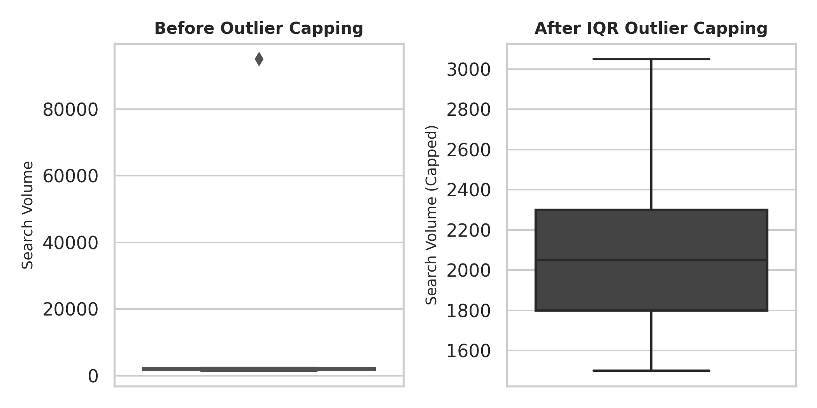

6. Correcting Incorrect Data Types
Dataset columns often get loaded with improper data types. This section ensures string dates are converted into standard datetime objects and numeric values stored as text are cast back to numeric types.
Code:
# Convert date columns and object types
print('Initial Data Types:')
print(df.dtypes)

for col in df.columns:
if 'date' in col.lower() or 'time' in col.lower():
df[col] = pd.to_datetime(df[col], errors='coerce')

print('\nUpdated Data Types:')
print(df.dtypes)
Output:
Initial Data Types:
Search_Query object
Search_Volume float64
Category object
Date_Recorded object
dtype: object

Updated Data Types:
Search_Query object
Search_Volume float64
Category object
Date_Recorded datetime64[ns]
dtype: object

7. Resolving Inconsistent Formatting
Text entries often contain leading/trailing spaces and inconsistent casing. Normalizing strings ensures correct grouping and count plots highlight clean category distributions.
Code:
# Normalize string formatting and visualize distributions
string_cols = df.select_dtypes(include=['object']).columns
for col in string_cols:
df[col] = df[col].astype(str).str.strip().str.lower()

sns.countplot(x=df['Category'])
plt.title('Category Frequency Distribution')
plt.show()
Output:
Formatted text columns sample:
Search_Query Category
0 google ai tech
1 python tutorial education
2 machine learning tech
3 python tutorial education
4 machine learning tech
Visualization Plot:
